
Rainbow family Activities

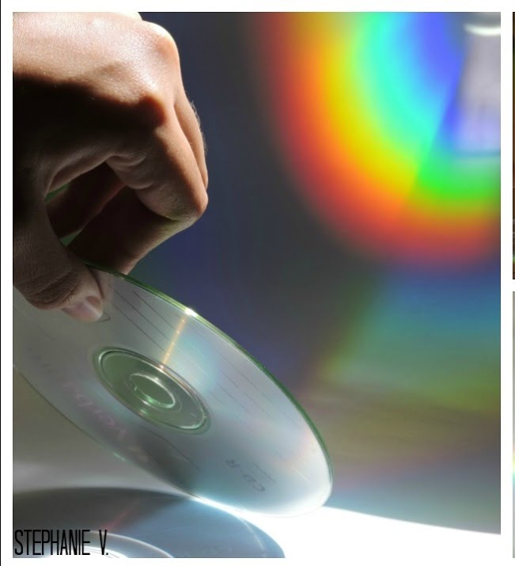

1, RAINBOW SCIENCE EXPERIMENT
Make a rainbow using a torch and CD (watch this video for instructions:)
https://www.youtube.com/watch?v=hU4RrhFJU9g

2, MAKE An EASTER RAINBOW CROSS

Maybe put in your window and send a in a picture to the church
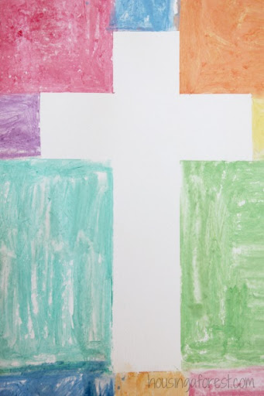


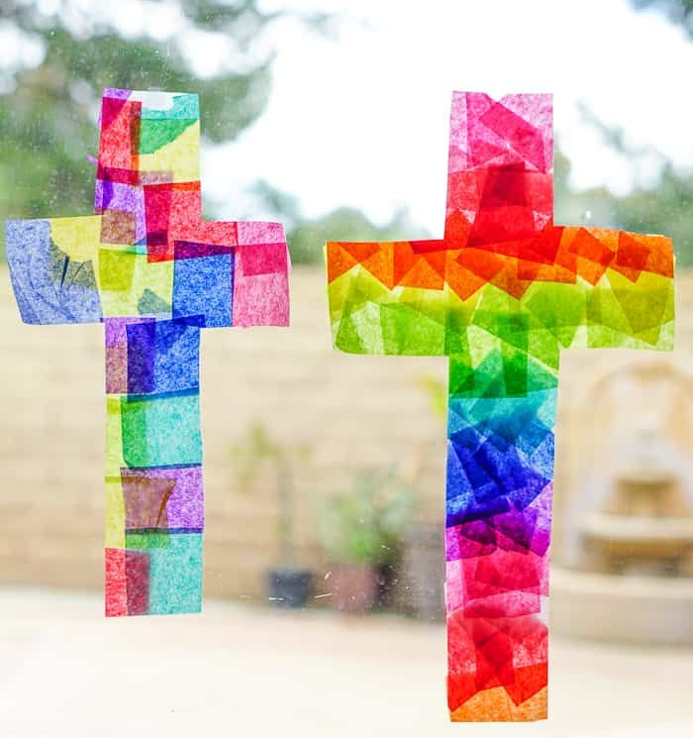


Rainbow Prayers
Many people are putting rainbows in their windows as a sign of hope. Did you know that the rainbow is also a symbol of God’s promise to care for us? We can pray through the colours of the rainbow. If you like, start by gathering something for each colour, and hold it as you pray.
Red- Red reminds us of a stop light, and of all the people who have to stay safe at home. Dear God, please look after all the people who have to stay at home. Help us all to do our part in keeping vulnerable people healthy. Please help us to stop this illness spreading fast.
Orange-Orange reminds us of the warmth of the sun or a cosy fire. Dear God, thank you for the warm love of our friends and families. Thank you for all the people who look after for us. Being cared for is like snuggling in a warm blanket. Thank you.
Yellow-Yellow reminds us of the bright light from a bulb or a lighthouse Dear God, please help the scientists to have bright ideas as they work very hard to make vaccines and tests to help us. Please help the leaders of our countries to be wise and to make decisions that will help all people.
Green- Green reminds us of the trees and flowers that are starting to grow. Dear God, thank you for the beauty of nature and for the hopefulness of spring. Please help us to keep healthy minds and bodies as we wait for this storm to pass.
Blue-Blue reminds us of the flashing lights of emergency services, and it’s the colour of the NHS. Dear God, thank you for our National Health Service and for all our emergency workers who are being so brave and dedicated. Please keep them safe and rested, and help us to make sure they have everything they need.
Purple-Purple is the colour of a sunset sky and of clouds after a storm. Dear God, just as Jesus calmed the storm when the disciples were frightened, so may we know your peace in these stormy days. May we rest in your love and comfort as we watch as the dark clouds fade into a beautiful sunset and the peace of night.
AMEN

Amfade into a beautiful sunset atpeace of night. Amen
